Test Cases for NZESportsLeague

Requirement to test | Test Data Input/Actions | Expected Outcomes | Actual Outcomes
- Main menu is displayed when the program is run. | Click on: | Displays:  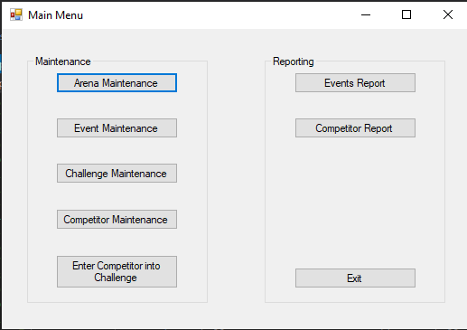
- Add a new arena with valid data in all fields. | Click on “Add Arena” and enter the following test data:  Arena Name: ASB Showgrounds  Street Address: 217 Green Lane West  Suburb: Epsom  City: Auckland  Phone Number: 096389969  Click on “Save Arena” | Displays:  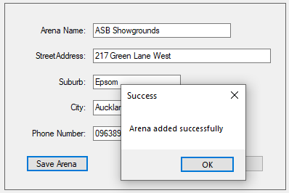  When “OK” is clicked on:  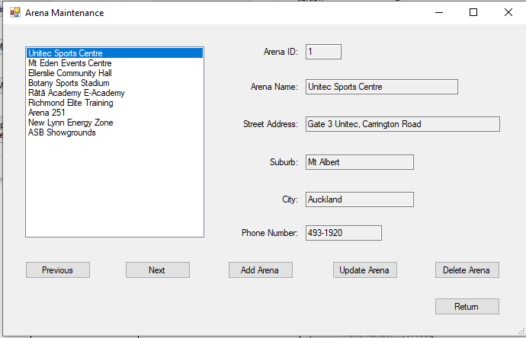
- Update an existing arena’s name with valid data. | Select “Unitec Sports Centre” in the list box and click on “Update Arena”.  Type: “Mt Albert Sports Centre” in the “Arena Name” field.  Click on “Save Changes”. | Displays:  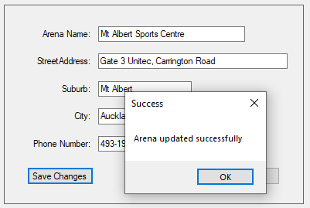  When “OK” is clicked on:  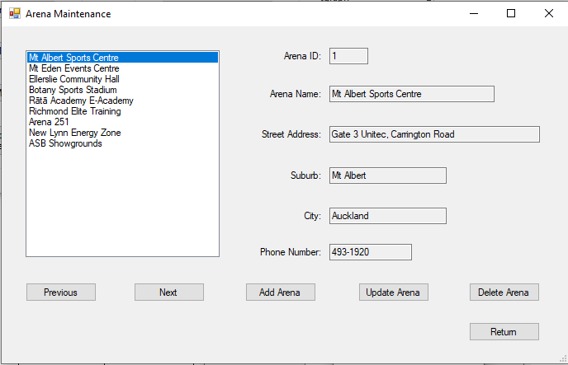
- Update an existing arena’s street address with valid data. | Select “New Lynn Energy Zone” in the list box and click on “Update Arena”.  Type: “45 Totara Ave” in the “Street Address” field.  Click on “Save Changes”. | Displays:  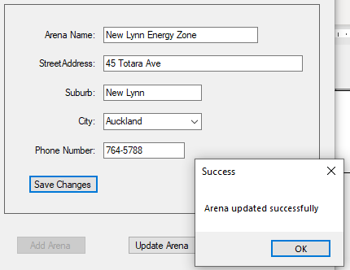  When “OK” is clicked on:  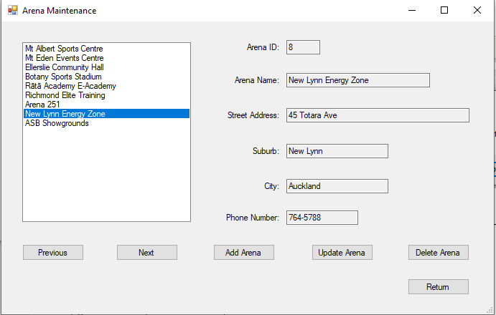
- Update an existing arena’s suburb with valid data. | Select “Richmond Elite Training” in the list box and click on “Update Arena”.  Type: “Swanson” in the “Suburb” field.  Click on “Save Changes”. | Displays:  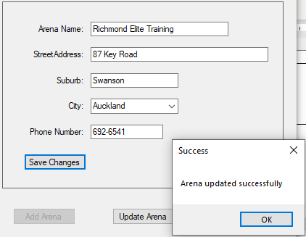  When “OK” is clicked:  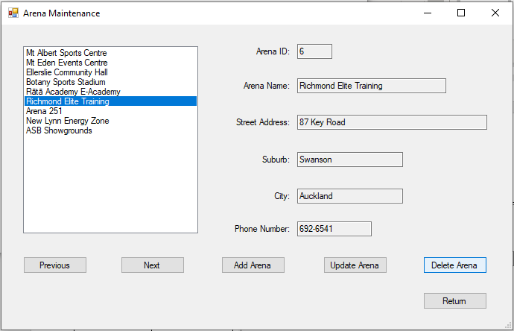
- Delete an existing arena that has no events. | Select “Ellerslie Community Hall” (in the list box) and click on “Delete Arena”. | Displays:  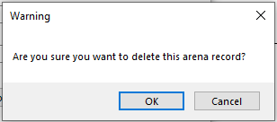  When “OK” is clicked:  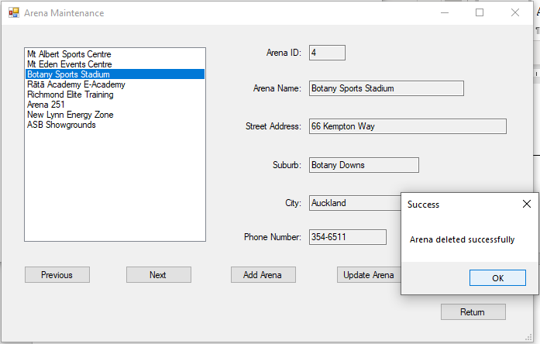
- Attempt to add a new arena with an invalid name but with valid data in all other fields. | Click on “Add Arena” and enter the following test data:  Street Address: 47 Totara Ave  Suburb: New Lynn  City: Auckland  Phone Number: 093010101  Click on “Save Arena”. | Displays:  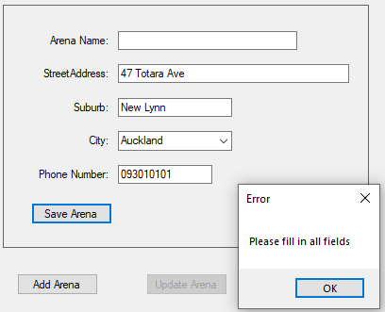  When “OK” is clicked on:  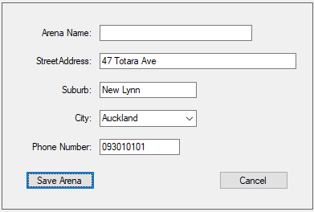
- Attempt to add a new arena with an invalid street address but with valid data in all other fields. | Click on “Add Arena” and enter the following test data:  Arena Name: Titirangi Showgrounds  Suburb: Titirangi  City: Auckland  Phone Number: 096389970  Click on “Save Arena”. | Displays:  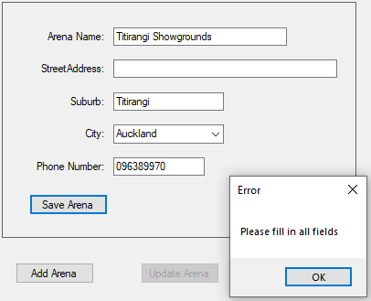  When “OK” is clicked:  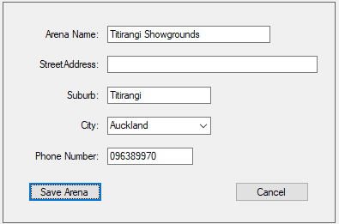
- Attempt to update an existing arena with an invalid name. | Select “Arena 251” in the list box and click on “Update Arena”.  Remove the Arena Name and click “Save Arena”. | Displays:  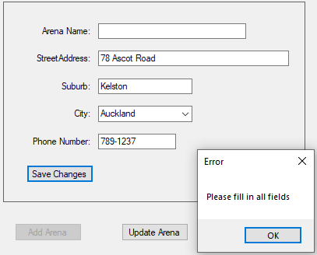  When “OK” is clicked:  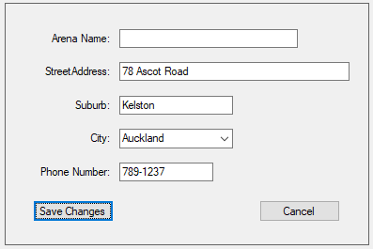
- Attempt to delete an existing arena that has events. | Select “Botany Sports Stadium” (in the list box) and click on “Delete Arena” | Displays:  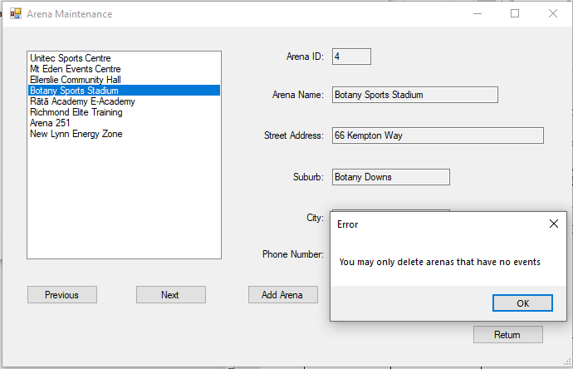  When “OK” is clicked:  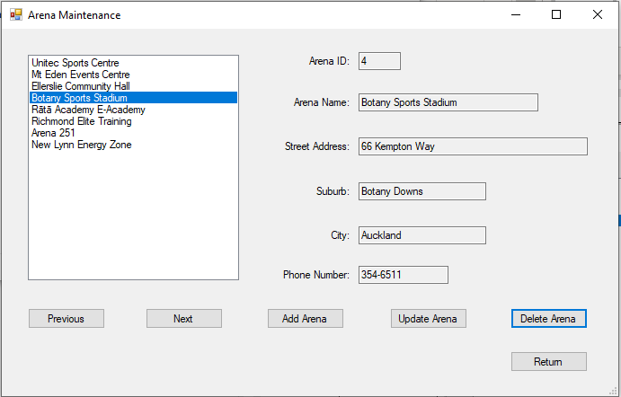
- Add a new challenge with valid data in all fields. | Click on “Add Challenge” and enter the following test data:  Challenge Name: Fortnite Round 1  Event: Central Auckland Regionals  Start Time: 16:00  Status: Scheduled  Capacity: 30  Click on: Save Challenge | Displays:  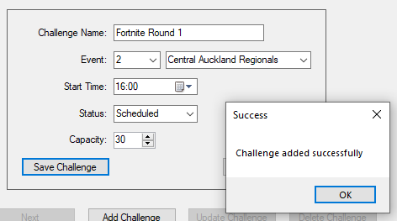  After clicking “OK”:  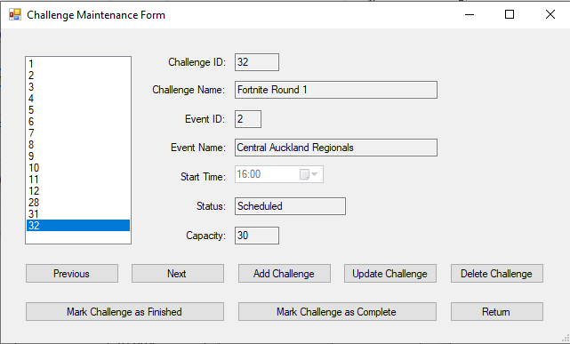
- Update an existing challenge’s capacity with valid data. | Select Challenge ID “1” in the list box and click on “Update Challenge”.  Scroll up to “10” in the “Capacity” number picker.  Click on “Save Challenge”. | Displays:  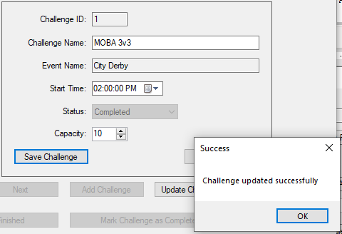  When “OK” is clicked on:  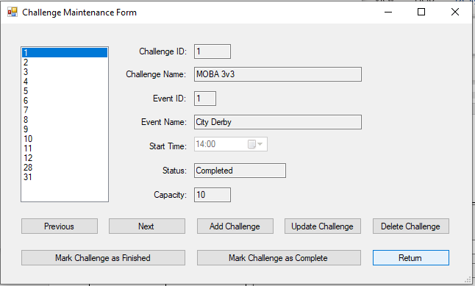
- Update an existing challenge’s name with valid data. | Select Challenge ID “2” in the list box and click on “Update Challenge”.  Change Challenge Name to: MOBA Invitational.  Click on “Save Challenge”. | Displays:  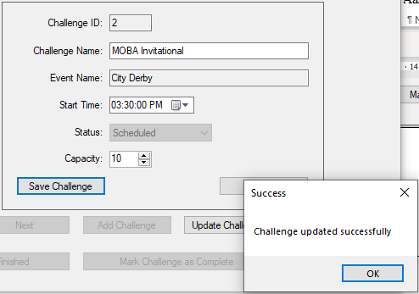  When “OK” is clicked:  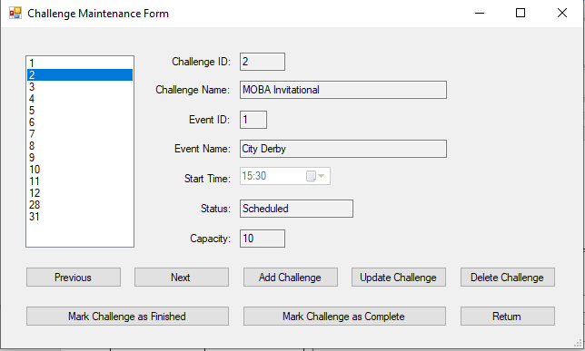
- Delete an existing challenge that has no entries. | Select Challenge ID “4” in the list box and click on “Delete Challenge”. | Displays:  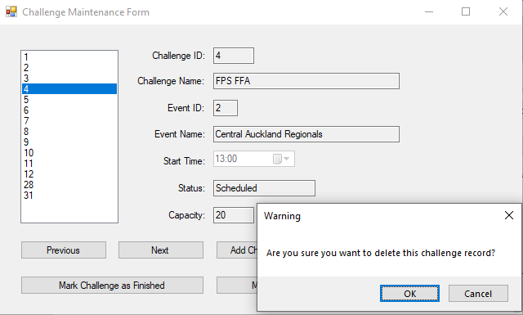  When “OK” is clicked:  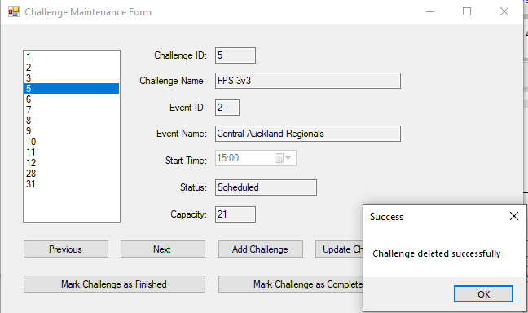
- Mark as finished an existing scheduled challenge. | Select Challenge ID “5” in the list box and click on “Mark Challenge as Finished”. | Displays:  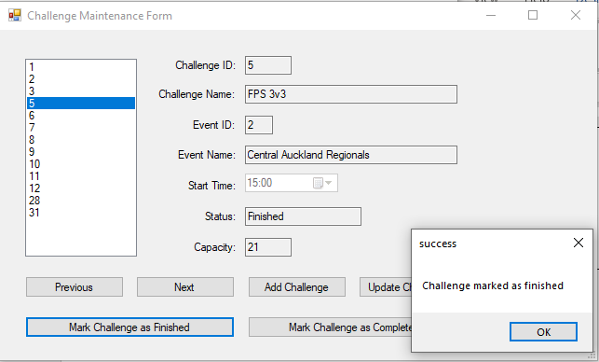
- Mark as completed an existing finished challenge. | Select Challenge ID “6” in the list box and click on “Mark Challenge as Complete”. | Displays:  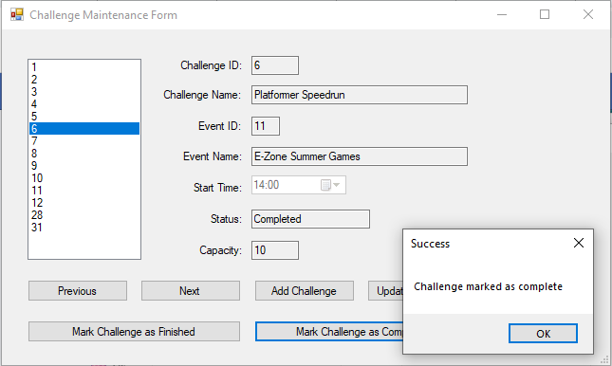
- Attempt to delete an existing challenge that has at least one entry. | Select Challenge ID “3” in the list box and click on “Delete Challenge”. | Displays:  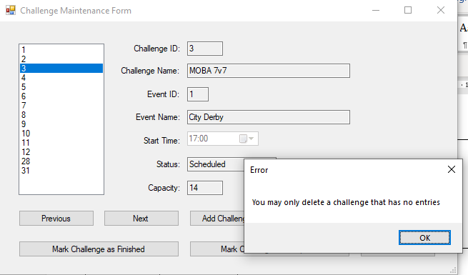  When “OK” is clicked:  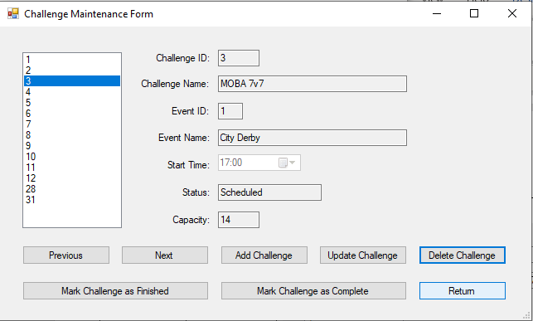
- Attempt to mark as finished an existing completed challenge. | Select Challenge ID “7” in the list box and click on “Mark Challenge as Finished”. | Displays:  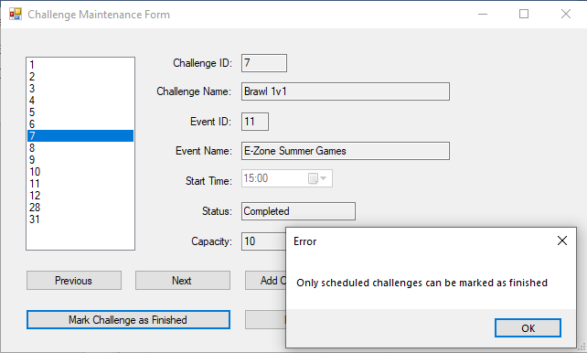
- Attempt to mark as completed an existing scheduled challenge. | Select Challenge ID “28” in the list box and click on “Mark Challenge as Complete”. | Displays:  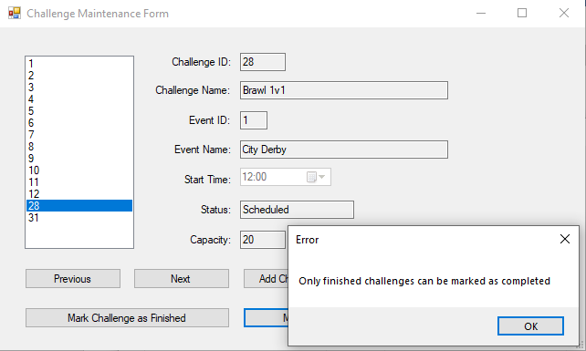
4.1 Add a new competitor record with valid data in all fields. | Click on “Add Competitor” and enter the following test data:  Username: Karanina  First Name: Anna  Last Name: McColl  Gender: Female  Date Of Birth: 05/09/1980  Email : annamccollnz@gmail.com  Click on “Save Challenge”. | Displays:  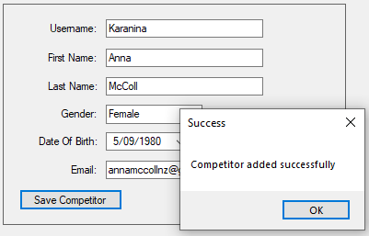  When “OK” is clicked:  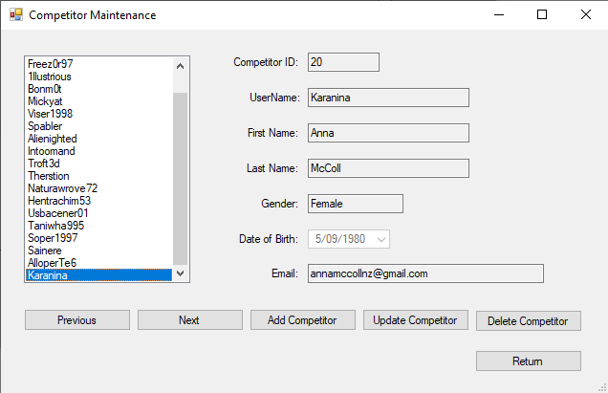
- Update an existing competitor record’s name with valid data. | Select Username: Maryrex from the list box and click on “Update Competitor”.  Change her last name to “Smith” and click on “Save Changes”. | Displays:  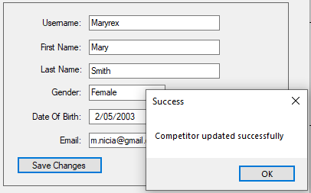  When “OK” is clicked:  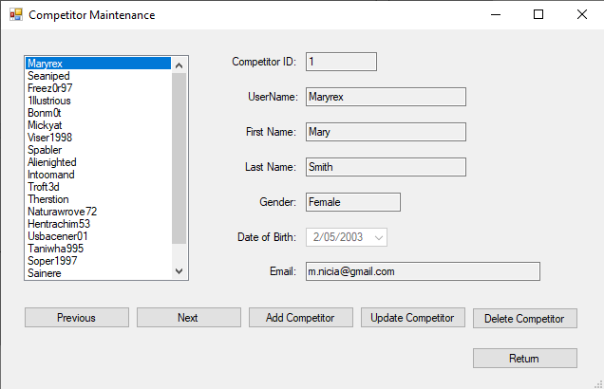
- Delete an existing competitor record that has no entries. | Select Username: Bonm0t from the list box and click on “Delete Competitor”. | Displays:  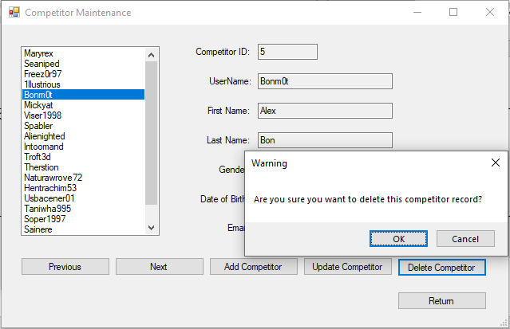  When “OK” is clicked:  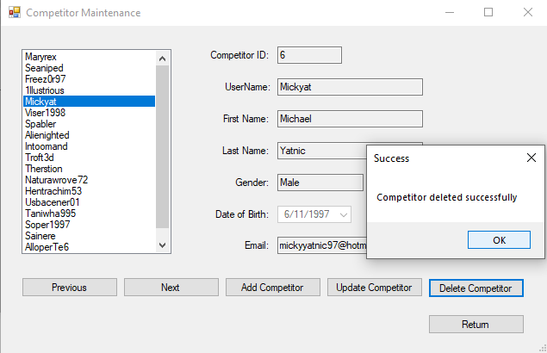
- Attempt to add a new competitor record with an invalid first name but with valid data in all other fields. | Click on “Add Competitor” and enter the following test data:  Username: Cybogoblin  First Name:  Last Name: McColl  Gender: Male  Date Of Birth: 07/10/1980  Email : cybogoblin@xtra.co.nz  Click on “Save Challenge”. | Displays:  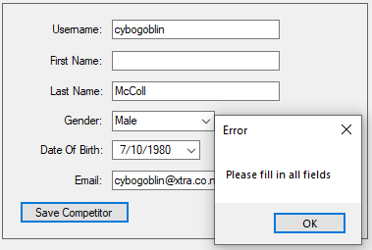
- Attempt to update an existing competitor record with an invalid first name. | Select Username: Naturawrove72 from the list box and click on “Update Competitor”.  Remove her first name and click on “Save Changes”. | Displays:  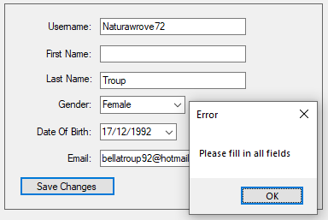
- Attempt to delete an existing competitor record that has entries. | Select Username: Mickyat from the list box and click on “Delete Competitor”. | Displays:  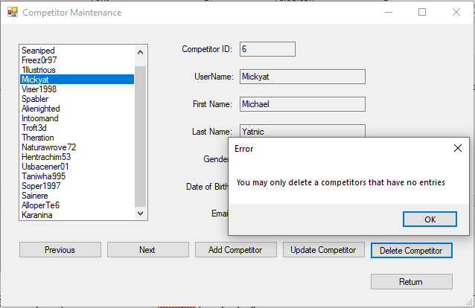  When “OK” is clicked:  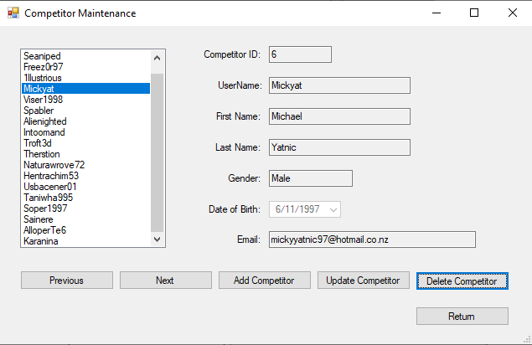
5.1 Add a new event with valid data in all fields. | Click on “Add Event” and enter the following test data:  Event Name: New Lynn Qualifying Tournament  Arena: New Lynn Energy Zone  Status: Scheduled  Capacity: 150  Date: 01/10/2020  Click on “Save Meeting”. | Displays:  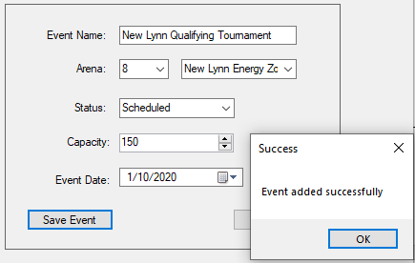  When “OK” is clicked:  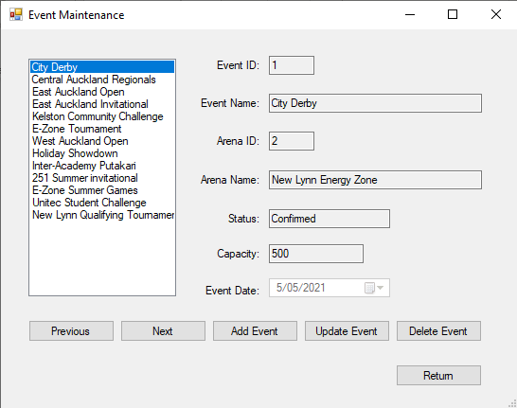
- Update an existing event’s name with valid data. | Select “City Derby” from the list box and click on “Update Competitor”.  Change the Event Name to “Auckland City Derby” and click on “Save Changes”. | Displays:  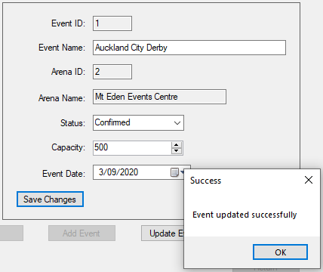  When “OK” is clicked”  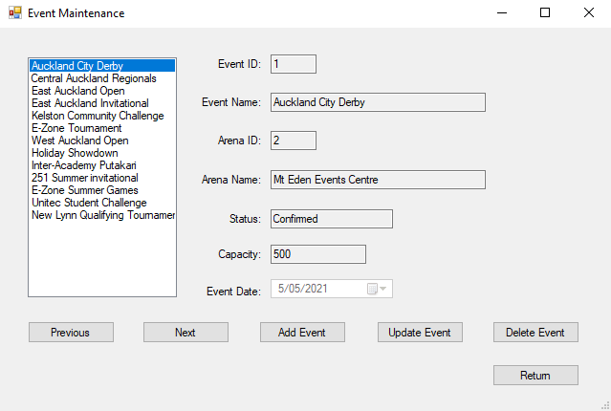
- Update an existing event’s date with valid data. | Select “Central Auckland Regionals” from the list box and click on “Update Competitor”.  Change the Event Date to “01/10/2021” and click on “Save Changes”. | Displays:  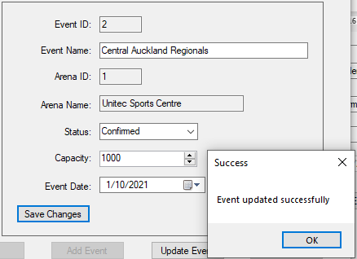  When “OK” is clicked:  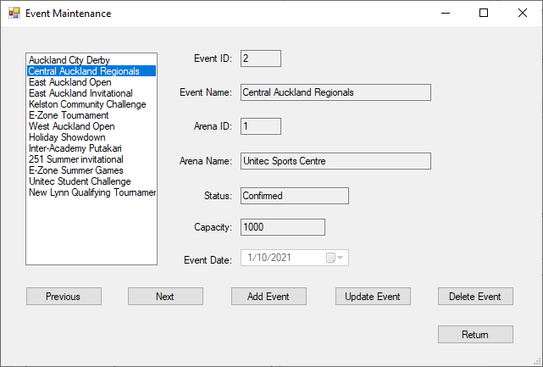
- Delete an existing event that has no challenges. | Select “East Auckland Invitational” from the list box and click on “Delete Competitor”. | Displays:  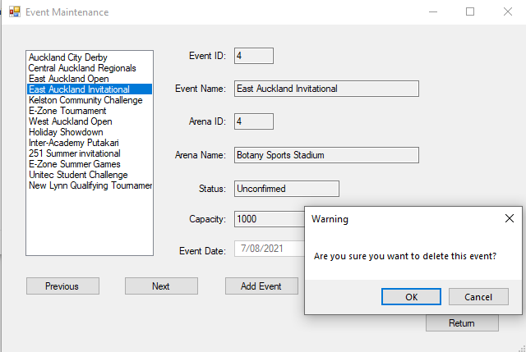  When “OK” is clicked:  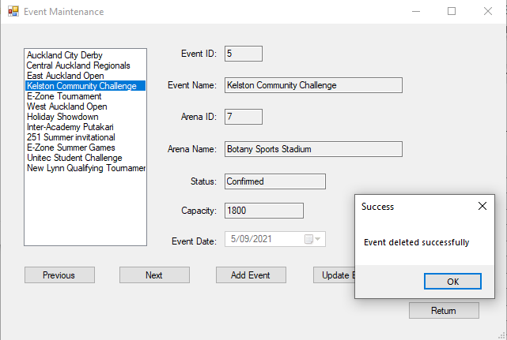
- Attempt to add a new event with an invalid name but with valid data in all other fields. | Click on “Add Event” and type the following information:  Arena: Unitec Sports Centre  Status: Scheduled  Capacity: 1000  Event Date: 31/10/2020  Click on “Save Meeting”. | Displays:  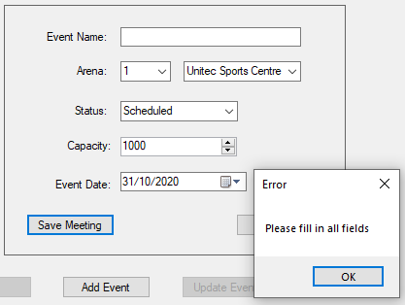
- Attempt to update an existing event with an invalid name. | Select “West Auckland Open” from the list box and click on “Update Event”.  Remove the Event Name and click on “Save Changes”. | Displays:  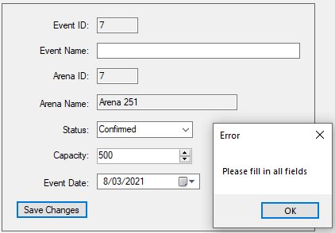
- Attempt to delete an existing event that has challenges. | Select “E-Zone Summer Games” in the list box and click on “Delete Event”. | Displays:  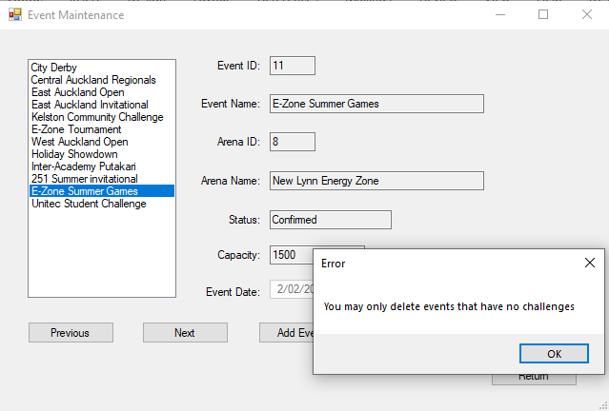
6.1 Add a competitor to a scheduled challenge | Select Competitor ID “1” in the Competitor Data Grid View.  Select Challenge ID “2” in the Challenge Data Grid View.  Click on “Add Entry”. | Displays:  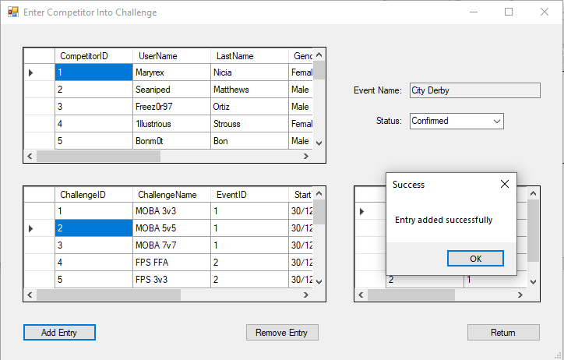  When “OK” is clicked on:  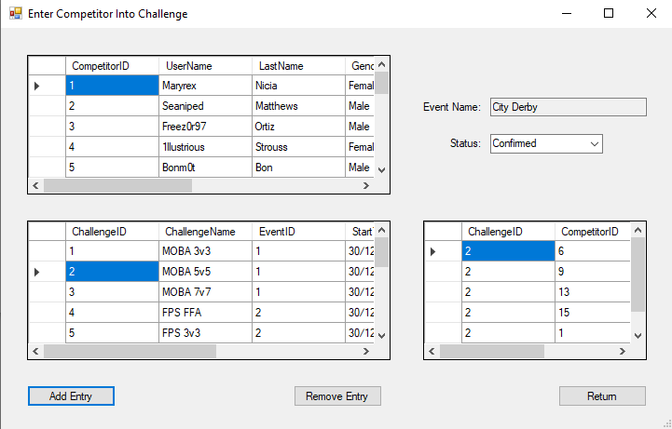
6.2 Remove a competitor from a finished challenge | Select Challenge ID “6” in the Challenge Data Grid View  Select Competitor ID “1” in the Entry Data Grid View.  Click on “Remove Entry”. | Displays:  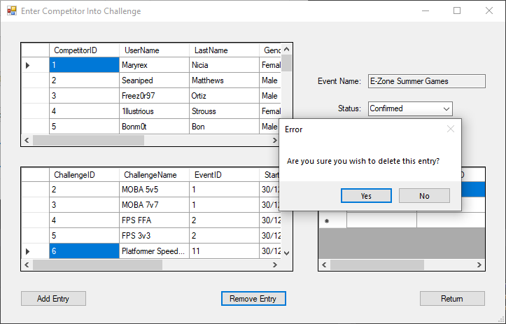  When “Yes” is clicked on:  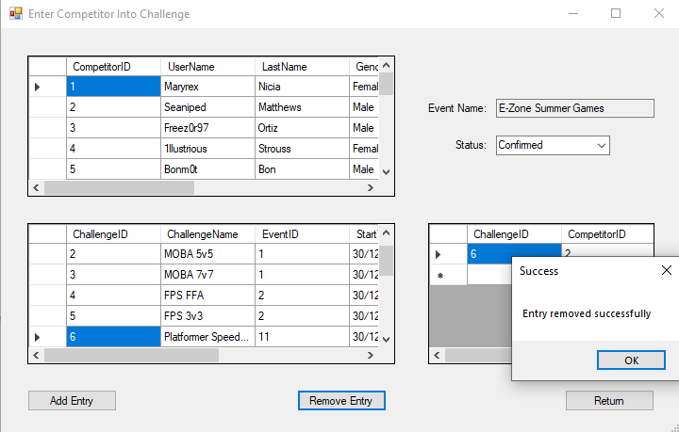
- Remove a competitor from a scheduled challenge | Select Challenge ID “10” in the Challenge Data Grid View  Select Competitor ID “2” in the Entry Data Grid View.  Click on “Remove Entry”. | Displays:  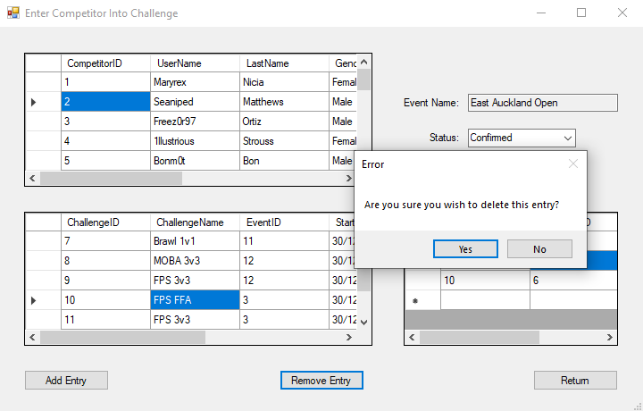  When “Yes” is clicked on:  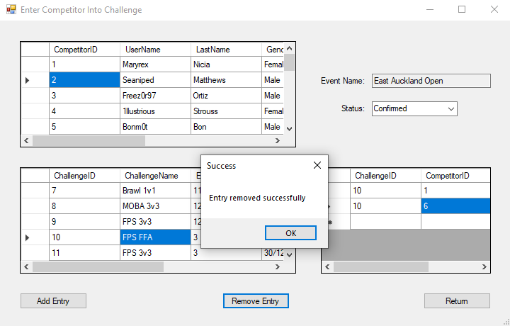
- Attempt to add a competitor to a finished challenge | Select Competitor ID “5” in the Competitor Data Grid View.  Select Challenge ID “6” in the Challenge Data Grid View.  Click on “Add Entry”. | Displays:  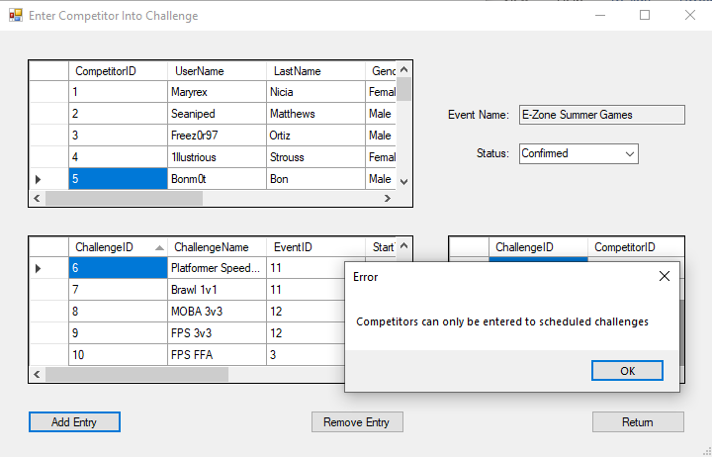  When “OK” is clicked on:  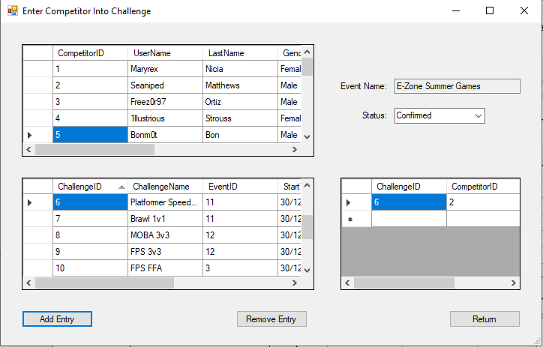
- Attempt to add a competitor to a completed challenge | Select Competitor ID “10” in the Competitor Data Grid View.  Select Challenge ID “7” in the Challenge Data Grid View.  Click on “Add Entry”. | Displays:  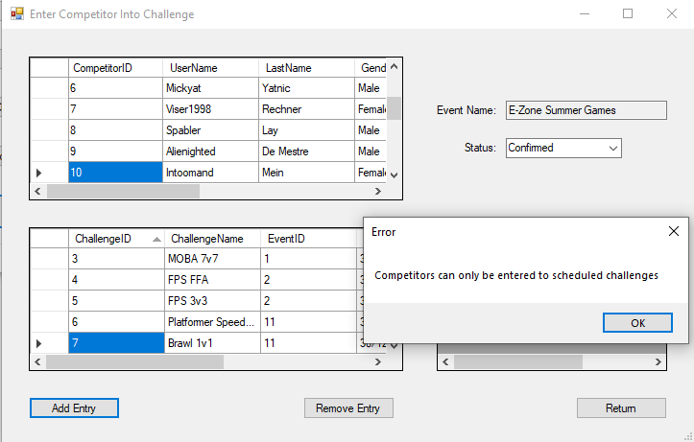  When “OK” is clicked on:  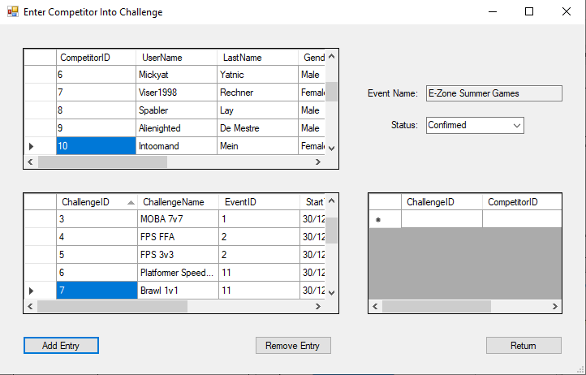
- Produce the report with all requested fields present. | Click on “Print Competitors”. | Displays:  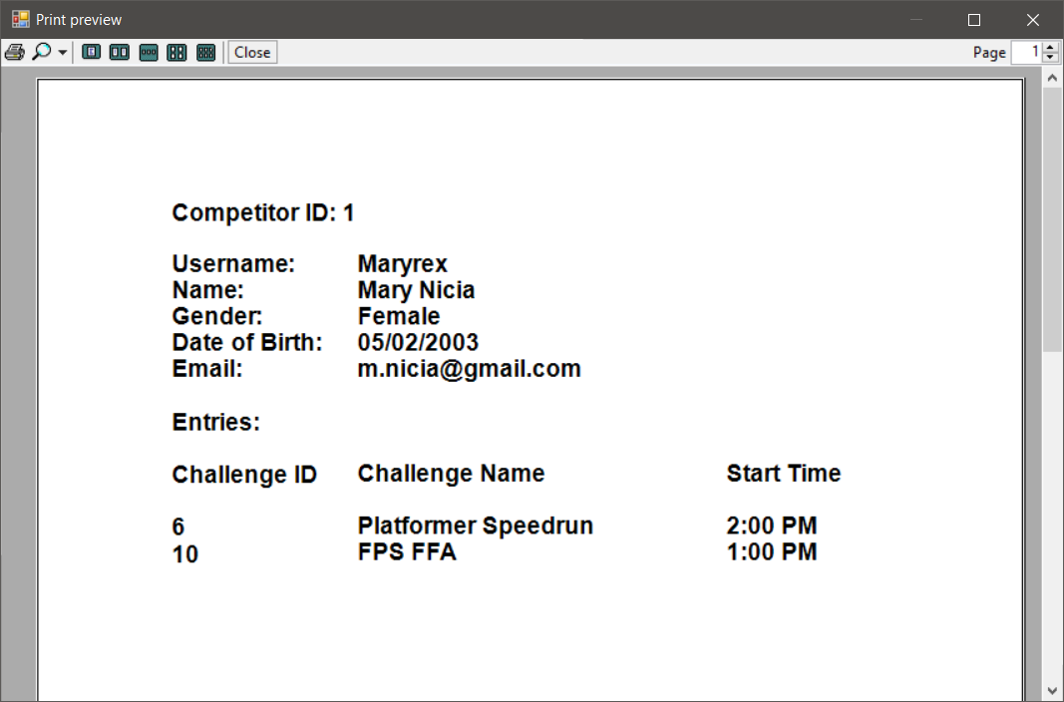
- Produce the report with all requested fields present. | Click on “Print Events”. | Displays:  